**AUTOMATED REAL-TIME ‘ALGORITHMIC TRADING’**

**HELPING BOT**

**A**

**Project Report**

***Submitted in partial fulfillment for the award of the degree***

***of***

**Bachelor of Technology in Information Technology**

***Submitted to***



**DEPARTMENT OF INFORMATION TECHNOLOGY UNIVERSITY INSTITUTE OF TECHNOLOGY**

**RAJIV GANDHI PROUDYOGIKI VISHWAVIDYALAYA, BHOPAL (M.P)**

***Submitted by***

**Srajan Agrawal (0101IT181058)**

**Yash Gupta (0101IT181065)**

**Vaibhav Khute (0101IT181061)**

***Under the Guidance of***

**Prof. Roopam Gupta**

**June 2022**

**DEPARTMENT OF INFORMATION TECHNOLOGY UNIVERSITY INSTITUTE OF TECHNOLOGY**

**RAJIV GANDHI PROUDYOGIKI VISHWAVIDYALAYA, BHOPAL (M.P)**



**CERTIFICATE**

This is to certify that the project entitled **“Automated Real-Time ‘Algorithmic Trading’ Helping Bot”** being submitted by **“Srajan Agrawal (0101IT181058), Yash Gupta (0101IT181065) and Vaibhav Khute (0101IT181061)”** students of **“Semester-VII”**, Department of Information Technology towards partial fulfillment of Bachelor of Technology in Information Technology from University Institute of Technology, RGPV, Bhopal (M.P) is a record of bonafide work carried out by them under my supervision.

|  |  |
| --- | --- |
| ***Guided by***  **Prof. Roopam Gupta**  **(Professor)**  **Department of Information Technology,**  **UIT, RGPV, Bhopal** | ***Forwarded by***  **Prof. Asmita Moghe**  **(Head of Department), HOD**  **Department of Information Technology,**  **UIT, RGPV, Bhopal** |

**DEPARTMENT OF INFORMATION TECHNOLOGY UNIVERSITY INSTITUTE OF TECHNOLOGY**

**RAJIV GANDHI PROUDYOGIKI VISHWAVIDYALAYA, BHOPAL (M.P)**



**DECLARATION**

We declare that project entitled **“Automated Real-Time ‘Algorithmic Trading’ Helping Bot”** is our own work conducted under the supervision of **“Prof. Roopam Gupta”**, Department of Information Technology, University Institute of Technology, RGPV, Bhopal (M.P).

We further declare that, to the best of our knowledge the project does not contain any work which has been submitted for the award of the degree either in the University or in any other University/Deemed University without proper citations.

|  |  |
| --- | --- |
| Place: Bhopal  Date: 27/05/2022 | ***Submitted by***  **Srajan Agrawal (0101IT181058)**  **Yash Gupta (0101IT181065)**  **Vaibhav Khute (0101IT181061)** |

**DEPARTMENT OF INFORMATION TECHNOLOGY UNIVERSITY INSTITUTE OF TECHNOLOGY**

**RAJIV GANDHI PROUDYOGIKI VISHWAVIDYALAYA, BHOPAL (M.P)**

**ACKNOWLEDGEMENT**

We would like to express our special thanks of gratitude to our professor Roopam Gupta and our HOD Dr. Asmita Moghe who provided us with this golden opportunity to this wonderful project on the topic “Algorithmic Trading” which also helped us in doing a lot of research and we came to know about so many new things. We are really thankful to them. Secondly, we would also like to appreciate all our team members who worked cordially and diligently to make this project a success in limited amount of time. This project helped us improve our skills and broaden our horizon of knowledge.

**OBJECTIVE**

To instill financial wisdom in common folk of India who lacks required financial knowledge to make profitable trading decisions in the financial markets. Through our automated real-time algorithmic trading: helping bot, a user would effortlessly get the real time opening and closing price of a stock. Moreover, our bot would provide a buy/sell indication to the user where signals would be based on few very efficient technical indicators. Through the culminated knowledge provided by our project about the risk and the margin of profit involved in the trading decision, a user could make an informed choice whether he wants to buy/sell a particular stock or not and about how much time he should wait in order to turn profits.

**TABLE OF CONTENTS**

|  |  |  |
| --- | --- | --- |
| **Sr. No.** | **Content** | |
| 1. | Introduction | * 1. Background of topic |
| * 1. Organization of report |
| * 1. Conclusion |
| 2. | Literature Survey | 1. Introduction |
| 1. Description of previous work |
| 1. Comparison of previous work |
| 1. Major problems |
| 1. Problem definition |
| 1. Objective and scope of work |
| 1. Proposed methodology |
| 1. Conclusion |
| 3. | Background of Previous Method | 1. Introduction |
| 1. Bollinger Bands Indicator |
| 1. Relative Strength Indicator (RSI) |
| 1. Moving Average Converge Divergence (MACD) Indicator |
| 1. Supertrend Indicator |
| 1. Conclusion |
| 4. | Proposed Technique | 1. Introduction |
| 2. Bollinger Bands Indicator |
| 3. Relative Strength Indicator (RSI)  4. MACD Indicator |
| 5. Supertrend Indicator |
| 6. Conclusion |
| 5. | Implementation and Result Analysis | 1. Introduction |
| 2. Implementation Tool Details |
| 3. Some Important Code, Research and  Front-end snapshots |
| 4. Result Analysis with previous methods |
| 5. Conclusions |
| 6. | Conclusion and Future Direction |  |

**CHAPTERS**

**1. Introduction**

**1.1 Background of topic**

Our project works on Algorithmic Trading which uses computer programs and technical indicators to make a wise ‘trade call’. Intra-Day Trading involves purchasing and selling stocks in a single day. In the case of day trading, individuals hold stocks for a few minutes or hours. A trader involved in such trade needs to close his/her transactions prior to the day’s market closure. It is popular for capitalising on small-scale fluctuations in NAV of stocks. Intraday trading requires proficiency in market matters, a thorough understanding of market volatility, and keen sense regarding the up and down in stock values. Therefore, it is performed mostly by experienced investors or traders.

**1.2 Organization of report**

Algorithmic trading uses a computer program that follows a defined set of instructions to place a trade. The trade, in theory, can generate profits at a speed and frequency that is impossible for a human trader. The defined sets of instructions are based on timing, price, quantity, or any mathematical model. Apart from profit opportunities for the trader, algo-trading renders markets more liquid and trading more systematic by ruling out the impact of human emotions on trading activities. We have made use of algorithmic trading in our project to incorporate the same principles in practice. Through our automated real-time algorithmic trading: helping bot, a user would effortlessly get the real time opening and closing price of a stock. Moreover, our bot would provide a buy/sell indication to the user where signals would be based on few very efficient technical indicators; optimized for Indian stock market. We have optimized these technical indicators so much so that they provide best profit with least amount of risk involved.

**1.3 Conclusion**

Through the culminated knowledge provided by our project about the risk and the margin of profit involved in the trading decision, a user could make an informed choice whether he wants to buy/sell a particular stock or not and about how much time he should wait in order to turn profits.

**2. Literature Survey**

**2.1 Introduction**

Technology has revolutionized the way financial-markets function and the way financial assets are traded. Two significant interrelated technological changes are investors using computers to automate their trading processes and markets reorganizing themselves so virtually all markets are now electronic limit order books. The speed and quality of access to such markets encourages the use of algorithmic trading (AT; AT denotes algorithmic traders as well), commonly defined as the use of computer algorithms to automatically make trading decisions, submit orders, and manage those orders after submission.

In the early days, algorithmic trading just did the simplest tasks faster—like buying something on one exchange and selling it on another, capturing the difference as an arbitrage profit. Then, they got a bit more sophisticated, using futures, or “options", to create profitable trades that enter and exit in milliseconds. In India, algorithmic trading is still less than 50%, and firms are relatively small in size. A significant number of algo-trading volumes is in pure arbitrage (trading between the National Stock Exchange or NSE and BSE, for instance).

AT initiate trades quickly when spreads are small and cluster their trades together. AT are more sensitive to human trading activity than humans are to AT trading activity. These are all consistent with AT closely monitoring the market for trading opportunities. If an algorithmic trader is constantly monitoring the market, the trader can break up their order into small pieces to disguise their intentions and quickly react to changes in market conditions. AT could also be trying to exploit small deviations of price from fundamentals. Moving beyond unconditional measures of AT activity we estimate profit models of AT using market condition variables incorporating the state of the limit order book and past volatility and trading volume. We find that AT are more likely to initiate trades when liquidity is high in terms of narrow bid-ask spreads and higher depth. Just as algorithms are used to monitor liquidity in the market, algorithms may also be used to identify and capitalize on short-run price predictability. AT liquidity demanding trades play a more significant role in discovering the efficient price than human trades. AT initiated trades have a more than 20% larger permanent price impact than human trades.

With several amendments over the years, India provides a good opportunity for algorithmic trading due to a number of factors such as colocation facilities and sophisticated technology at both the major exchanges; a smart order routing system; and stock exchanges that are well-established and liquid. Given the rapidly growing trend and demand of HFT and Algorithmic Trading in developing economies & emerging markets, there have been efforts by various exchanges to educate their members and develop the skill sets required for this technology-driven field.

**2.2 Description of Previous Work**

Algorithmic trading was introduced and allowed in India in 2008 by the Securities and Exchange Board of India (Sebi). Initially, it started with Direct Market Access (DMA) and was restricted to institutional investors only, but due to the cost advantage and better execution, the trading community welcomed it with open arms. Exchanges has also played an important role in its adoption by offering co-location server 'racks' on lease to broking firms in June 2010, to improve trading speed and align with international markets.

Algorithmic trading strategies involve making trading decisions on the basis of pre-set rules that are programmed into a computer. A trader or investor writes code that executes trades on behalf of the trader or investor when specified conditions are met. The pre-set rules are generally based on timing, price, quantity, or any mathematical model. Since algorithms are written beforehand and are executed automatically, the main advantage is speed. Besides, it promotes features such as automation, eliminates human intervention and emotions, minimizes slippages, allows flexibility and promotes ease of use, provides extensive data mining and explorations, and safeguards and warning systems against most common human errors.

The beauty of Algo trading is that it comes with aspects such back-testing, where individuals can run their strategy and see potential outcomes. One could also try simulation in Algo trading to test strategy in real-time but with no actual trades to exchange. However, one should only deploy algorithms when they are completely sure. This surety is achieved by deploying the use of technical indicators with their default or optimized parameter values.

**2.3 Comparison of previous work**

|  |  |  |
| --- | --- | --- |
| **RESEARCH PAPER** | **AUTHOR(S)** | **OBSERVATION** |
| “A Study on Technical Analysis and its usefulness in Indian Stock Market” Mirror, 3, (2), 159-165. ISSN: 2249-8117 | Dr. Asha E. Thomas  Asst. Professor in P.G. Dept. of Commerce St. Paul’s College, Kalamassery | Technical analysis tries to do away with the complexity of trading in market by basing everything on **price action**, which includes all the economic analysis. |
| “A Study on the Technical Analysis of NSE Towards it Stocks with Reference to Indian Stock Market” International Journal of Advances in Management and Economics ISSN: 2278-3369 | Valarmathi A, Kowsalya P  Vivekananda Institute of Management Studies, Coimbatore, India. | Technical charts hold good for short term movement; particularly for intraday trading then for the long-term investment decisions. |
| “Investment Decision Making Using Technical Analysis: A Study on Select Stocks in Indian Stock Market”. IOSR Journal of Business and Management e-ISSN: 2278-487X, p-ISSN: 2319-7668. | Pushpa BV, Sumithra C.G, Madhuri Hegde  M.P. Birla Institute of Management, Associate Bharatiya Vidya Bhavan, Bengaluru. | Indicators such as RSI & MACD gives strong signals as to the direction in which the company is heading as well as it helps to identify oversold, overbought and trend reversals. |
| “A Comparative Study on Technical Analysis by Bollinger Band and RSI” International Journal in Management and Social Science ISSN: 2321-1784 | Shah Nisarg Pinakin, Patel Taral Manubhai  B.V. Patel Institute of BMC & IT, Bardoli, Gujarat. | Bollinger Band give accurate signal, better profit and higher return compared to RSI. |
| “Optimization of MACD and RSI indicators: An Empirical Study of Indian Equity Market for Profitable Investment Decisions” Asian Journal of Research in Banking and Finance Vol. 5, No, pp.13-25. ISSN 2249-7323 | Dr. Yogesh D Mahajan, Associate Professor, Symbiosis International University.  Dr. Krishnamurthy Inumula Symbiosis institute of International Business, Pune | The optimum MACD and optimum RSI indicators are useful for profitable investment strategy and accepts the hypothesis that optimized MACD and RSI indicators are more profitable than the conventional buy and hold strategy. Results indicated that the number of trading cycles got significantly reduced by using optimized MACD and RSI Indicators. |
| “Simulation of Technical Indicators for Better Profits in the Indian Stock Market” International Journal of Recent Technology and Engineering ISSN: 2277-3878 | Krishna Murthy Inumula, Anupama Tadamarla, K.Deeppa | The optimized MACD and RSI outperformed the standard MACD, standard RSI and Buy & Hold strategy.  The average optimum MACD period is 10, 8, 11 and average RSI period is 10 for Nifty50. |

**2.4 Major Drawbacks of Current Algorithmic-Trading Infrastructure**

A few years ago, a company called Knight Capital launched a new algorithmic trading software, and put it to work. But there was a problem. It was losing £10 million every minute, and by the time they took it down, the company had lost £440 million. A similar event in India during a recent Diwali (2021) mahurat trading session (a short trading session on the festival, which is otherwise a holiday) saw prices in certain derivatives plunge nearly 20%. This, it was discovered later, was due to a faulty algorithmic trading software at a broker. All trades on this day were annulled.

The problem was a rogue algorithm in both these cases. And these instances are visible manifestation of a phenomenon that has been taking hold for a while now: machines have been quietly easing out humans from modern stock markets. India allowed algorithmic trading only in 2008, but algos control nearly a third of all trades already. In the West, where the phenomenon first surfaced nearly three decades ago, algos were running about 50% of US equity trading volumes by 2012. In the foreign exchange markets, which run 23 hours a day, algorithms account for 80% of the trading volumes.

Reflexivity is when the very act of observing or measuring something changes it. If you’re influential, and say the market is bullish, it makes people buy, and that buying makes it more bullish. Technology amplifies reflexivity, especially when the creators of the technology have no clue about the reflexive nature of markets. Imagine that you programmatically buy stocks based on your algorithm, and you’re so profitable that you get a lot of money from investors. Now you’re the biggest entity in town; and everyone knows. If your stocks fall, say 30%, and your algorithm wants to sell, it simply cannot because everyone will sell ahead of you. Your mathematical model assumed that the price on the screen is what you’ll get if you buy or sell, but the reality is different because of your size and impact you make on the markets.

But complex algos will, at some point, take over the Indian stock market. What happens when the math goes wrong? In that scenario we will need an algorithm which is so highly optimized that it yields most amount of profits when the market is in a good condition and also makes least amount of loss when the market is in a bad condition.

**2.5 Problem definition**

We found certain inconsistencies in the traditional trading techniques and that’s why we worked our way towards algorithmic trading. But the algorithmic-trading infrastructure too faces several challenges. In order to overcome those challenges, we have built this project which would provide the user with the sufficient amount of knowledge and time to make an informed decision regarding placing a particular trade or not, i.e., the final ‘action call’ would be in the hands of user. To facilitate that, we have optimized the parameters of some very efficient technical indicators such as Bollinger Bands, RSI, MACD and Supertrend to make our algorithm most profitable and least loss making.

**2.6 Objective and scope of work**

People in India, generally lacks financial literacy and refrain themselves from trading in stock market. So, we offer an optimal solution to such people that is ‘algorithmic trading’: helping bot; which is less risky. Our project works on Algorithmic Trading which uses computer programs and technical indicators to make a wise ‘trade call’. Intraday trading requires proficiency in market matters, a thorough understanding of market volatility, and keen sense regarding the up and down in stock values. Therefore, it is performed mostly by experienced investors or traders. But algorithmic trading uses a computer program that follows a defined set of instructions to place a trade. The trade, in theory, can generate profits at a speed and frequency that is impossible for a human trader. The defined sets of instructions are based on technical indicators which give us a fair idea of volatility, momentum and trend of stock market. We have made use of algorithmic trading in our project to incorporate the same principles in practice. Through our automated real-time algorithmic trading: helping bot, a user would effortlessly get the real time opening and closing price of a stock. Moreover, our bot would provide a buy/sell indication to the user where signals would be based on few very efficient technical indicators.

With the use of latest technology tools such as artificial intelligence and machine learning, and use of big data, Algo trading is poised to further revolutionize trading. In the developed markets currently, the share of algorithmic trading in volume terms stands around 70-80 per cent, while in India it is approximately at 50 per cent. In the coming years, Algo will capture market share in excess of 95 per cent with volume growing many folds. So, the future of trading is Algo and Algo is the future. That’s why these technical indicators will definitely keep evolving and people will keep optimizing their parameters in order to develop better trading strategies.

**2.7 Proposed methodology**

In order to do away with the irregularities and inconsistencies of algorithmic trading infrastructure, we have proposed a new bot. This bot would make use of several technical indicators to study the live data of a particular stock. Then it would produce meaningful graph and patterns to analyse an ongoing or upcoming trend. Using this analysis, the different indicators which study the different market conditions such as volatility, momentum and trend would provide different buy/sell signals to the user. Thus, a user would get a culmination of different suggested choices heavily based on some most powerful buy/sell algorithms. This would help a user to make an informed decision, making it possible for him to have the end action call reserved to him. Not only this, we have also optimised these technical indicators as per our Indian market’s condition so as to provide the most accurate analysis and prediction.

We have made use of the following technical indicators and have optimized their parameters:

1. Bollinger Bands.
2. Relative Strength Index (RSI).
3. Moving Average Convergence Divergence (MACD).
4. Supertrend.

**2.8 Conclusion**

We have successfully chosen the best technical indicators suitable for the Indian Financial Markets and we have also worked upon improving their overall profitability and efficiency by optimizing them as per India’s current market conditions.

**3. Background of Previous Method**

**3.1 Introduction**

Algorithmic trading strategies make use of technical indicators which are a powerful mathematical tool that provides traders with a fair idea of volatility, momentum and trend of the market condition along with stock’s current flow. Using these indicators traders devise a strategy so as to when to buy or sell a particular stock or not.

**3.2 Bollinger Bands Indicator**

A Bollinger Bands is a technical analysis tool defined by a set of trendlines plotted two standard deviations (positively and negatively) away from a Simple Moving Average (SMA) of a security's price, but which can be adjusted to user preferences. There are three lines that compose Bollinger Bands: A simple moving average (middle band) and an upper and lower band. The upper and lower bands are typically 2 standard deviations +/- from a 20-day simple moving average, but they can be modified. Bollinger Bands indicator helps traders to study volatility of the market.

Bollinger Bands work on this formula: -

​BOLU = MA (TP, *n*) + *m*∗*σ* [TP, *n*]

BOLD=MA (TP, *n*) − *m*∗*σ* [TP, *n*]

**where:**

BOLU = Upper Bollinger Band

BOLD = Lower Bollinger Band

MA = Moving average

TP (typical price) = (High+Low+Close) ÷ 3

*n* = Number of days in smoothing period (typically 20)

*m*=Number of standard deviations (typically 2)

*σ* [TP, *n*] = Standard Deviation over last *n* periods of TP​

Many traders believe the closer the prices move to the upper band, the more overbought the market, and the closer the prices move to the lower band, the more oversold the market.

**3.3 Relative Strength Index (RSI) Indicator**

The relative strength index (RSI) is a momentum indicator used in technical analysis that measures the magnitude of recent price changes to evaluate overbought or oversold conditions in the price of a stock or other asset. The RSI is displayed as an oscillator (a line graph that moves between two extremes) and can have a reading from 0 to 100.

Traditional interpretation and usage of the RSI are that values of 70 or above indicate that a security is becoming overbought or overvalued and may be primed for a trendreversal or corrective pullback in price. An RSI reading of 30 or below indicates an oversold or undervalued condition.

The RSI is computed with a two-part calculation that starts with the following formula:

*RSI(*step one) ​= 100 – {100 / [1 + Average gain/Average loss​]}

*RSI(*step two) ​= 100 – {100 / [1 + [(Previous Average Gain * 13 + Current gain)/ (Previous Average Loss * 13 + Current Loss)]}

**3.4 Moving Average Convergence Divergence (MACD) Indicator**

Moving average convergence divergence (MACD) is a trend-following momentum indicator that shows the relationship between two moving averages of a security’s price. The MACD is calculated by subtracting the 26-period exponential moving average (EMA) from the 12-period EMA. The result of that calculation is the MACD line. A nine-day EMA of the MACD called the "signal line," is then plotted on top of the MACD line, which can function as a trigger for buy and sell signals. Traders may buy the security when the MACD crosses above its signal line and sell—or short—the security when the MACD crosses below the signal line.

MACD = 12Period EMA – 26Period EMA

**3.5 Supertrend Indicator**

A ‘Supertrend’ indicator is one, which can give you precise buy or sell signal in a trending market. ‘Supertrend’ is a trend-following indicator just like moving averages and MACD (moving average convergence divergence). It is plotted on prices and their placement indicates the current trend.

The indicator is easy to use and gives an accurate reading about an ongoing trend. It is constructed with two parameters, namely period and multiplier. The default values used while constructing a supertrend indicator are 10 for average true range or trading period and 3 for its multiplier. The average true range (ATR) plays an important role in 'Supertrend' as the indicator uses ATR to calculate its value. The ATR indicator signals the degree of price volatility.

The buy and sell signals are generated when the indicator starts plotting either on top of the closing price or below the closing price. A buy signal is generated when the ‘Supertrend’ closes above the price and a sell signal is generated when it closes below the closing price. It also suggests that the trend is shifting from descending mode to ascending mode. Contrary to this, when a ‘Supertrend’ closes above the price, it generates a sell signal as the colour of the indicator changes into red.

TR = Max [(current high –current low), Abs (current high – previous close​), Abs (current low – previous close​)]

ATR=(1/n)

TR is the true range

n is the number of periods or trading days

**3.6 Conclusion**

Default parameters used for various technical indicators: -

Bollinger Bands: Periods = 20 and Standard Deviation = 2

RSI: Range = 30 to 70

MACD: Fast Period = 12, Slow Period = 26, Signal Period = 9

Supertrend: ATR = 10, Multiplier = 3

**4. Proposed Technique**

**4.1 Introduction**

We have optimized the values of the parameters of all technical indicators that we have used in our project. And on the basis of that we have developed a buy or sell signal and live chart analysis. This will facilitate user to make an informed decision about placing a particular trade or not. Through our extensive research and optimization algorithms, we have optimized the parameters of all technical indicators that we have used.

**4.2 Bollinger Bands Indicator**

We have optimised Bollinger Bands indicator to make it efficient for NSE and BSE (Indian financial markets) and then with the help of our proposed parameters, we have built a buy/sell signal graph. As we know, the standard value of periods of SMA taken in Bollinger Bands is 20 and the standard deviation factor used is 2. We have proposed the use of SMA period as 16 which yielded the most profitable and consistent result in our research. Using our parameter in buy/sell strategy of Bollinger Bands algorithm, we provide user with following chart and signal.

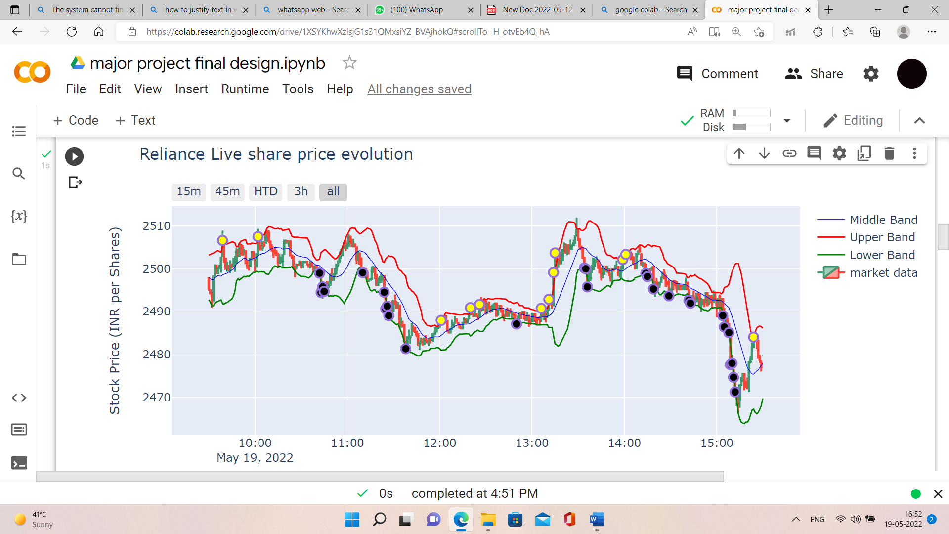

Black Colour Dot – BUY SIGNAL

Yellow Colour Dot – SELL SIGNAL

Periods Used – 16

**4.3 Relative Strength Index (RSI) Indicator**

Similarly, we tried optimizing RSI indicator based on the same approach of our research but we found a conclusory result that since RSI is a momentum indicator and momentum is a very fickle part of stock market so it is not wise to bound RSI in a range. Therefore, we propose an alternate option to user; where based on the current market condition, he will automatically be provided with the best optimal RSI range against the most commonly used RSI range of 30 to 70. Using this approach in RSI algorithm, we provide user with following chart and lines.

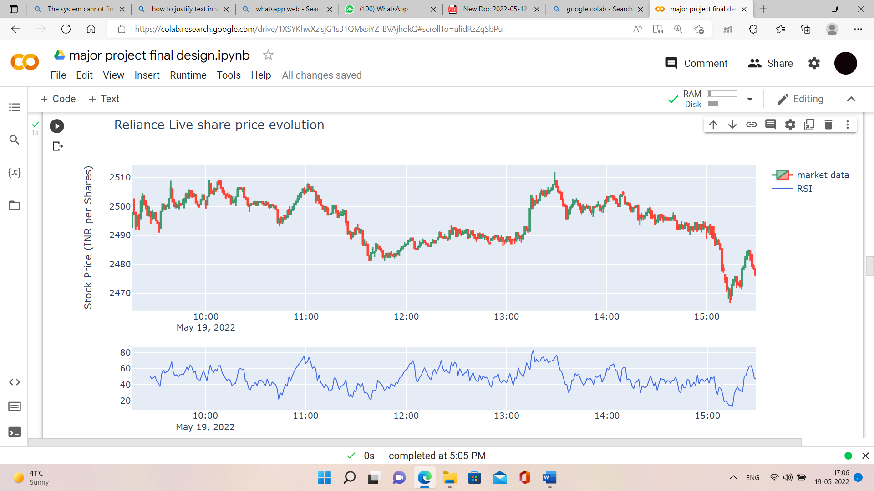

Here, the RSI range suggested by our algorithm to user is 20 to 80 because there was a high momentum in the market.

Blue Colored Line – Trend Line of RSI

**4.4 Moving Average Convergence Divergence (MACD) Indicator**

We have optimised MACD indicator to make it efficient for NSE and BSE (Indian financial markets) and then with the help of our proposed parameters, we have built a trend signal-line graph. As we know, the default slow period of MACD is 26-period exponential moving average (EMA) and the default fast period of MACD is 12-period EMA. And the default signal line is of nine-day EMA. We have proposed the use of slow period EMA as 23, fast period EMA as 14 and the EMA period for signal line as 10 which yielded the most profitable and consistent result in our research. Using our parameter in buy/sell strategy of MACD algorithm, we provide user with following chart and trend line.

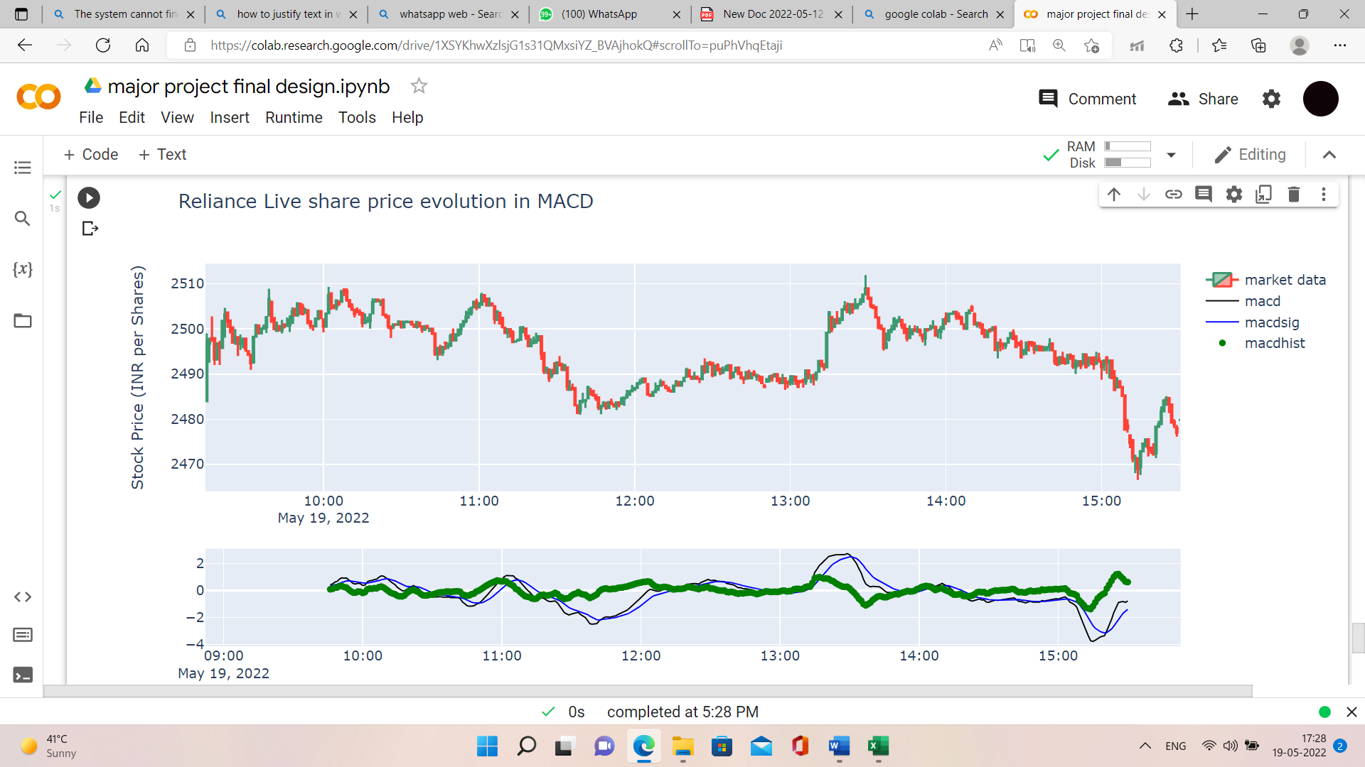

Green coloured Line – Trend Line of MACD

Slow period EMA = 23

Fast period EMA = 14

EMA period for signal line = 10

**4.5 Supertrend Indicator**

We have optimised Supertrend indicator to make it efficient for NSE and BSE (Indian financial markets) and then with the help of our proposed parameters, we have built a supertrend-line graph. As we know, the default values used while constructing a supertrend indicator are 10 for average true range (ATR) or trading period and 3 for its multiplier. We have proposed the use of 7 for average true range (ATR) or trading period and 2.5 for its multiplier as these values yielded the most profitable results in our optimisation algorithm. Using our parameters in buy/sell strategy of Supertrend indicator algorithm, we provide user with the following chart and trend lines.

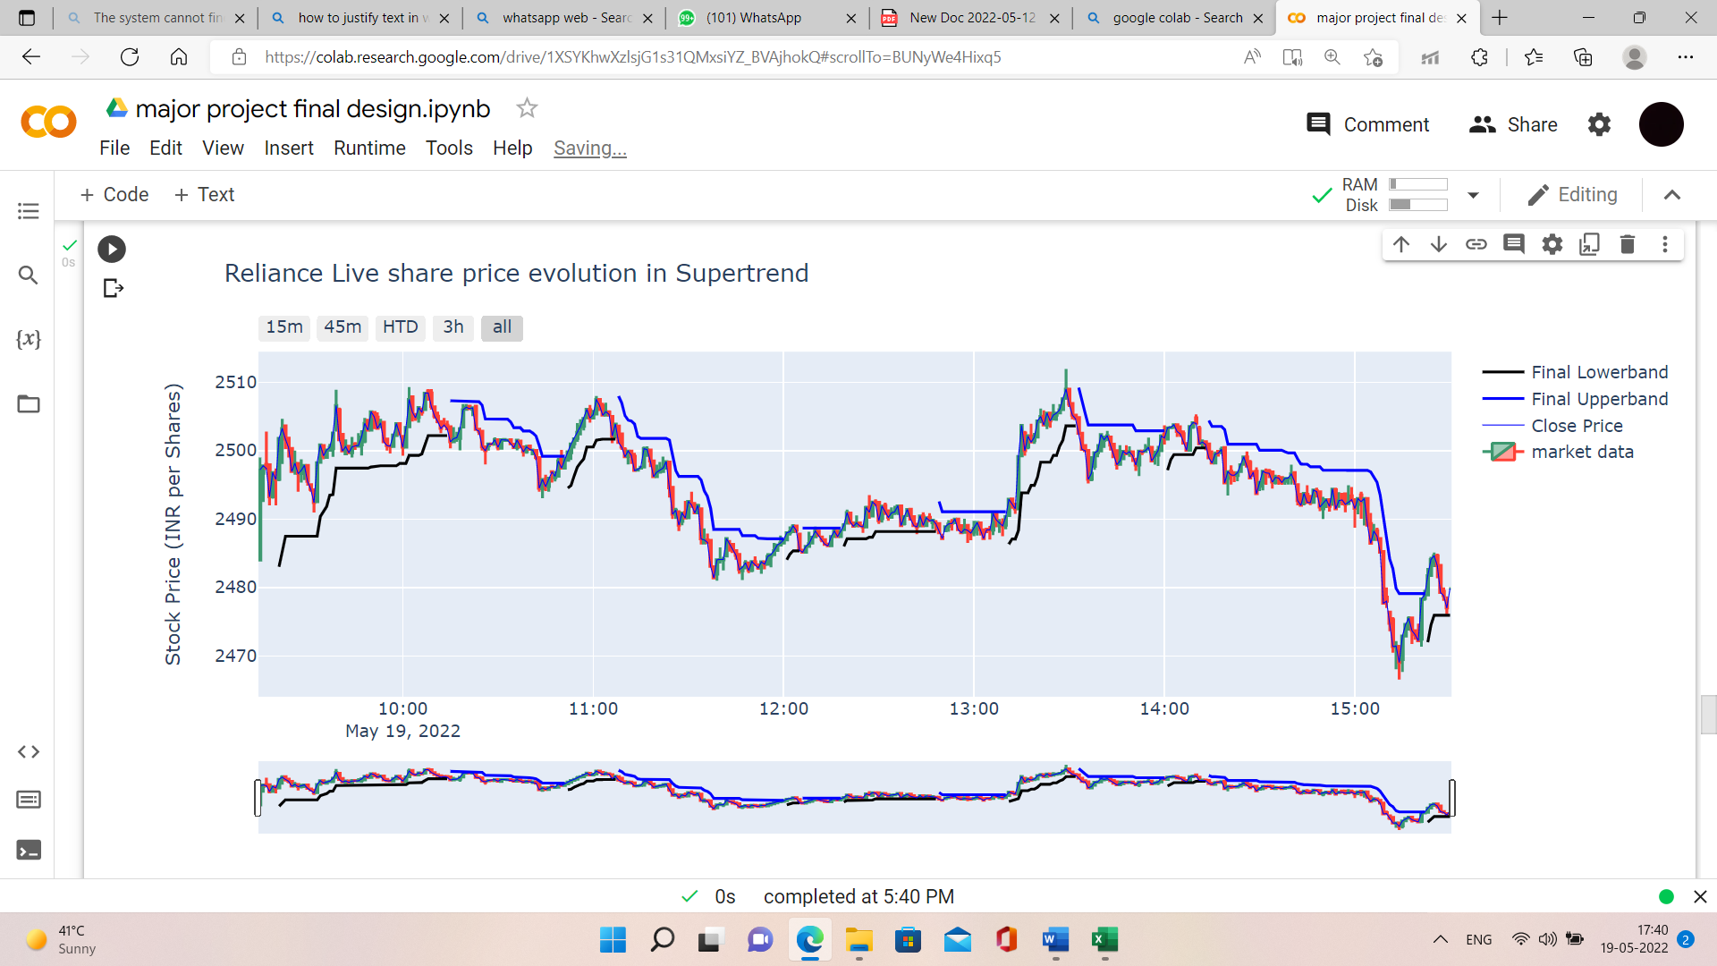

Blue Line – SELLING PERIOD

Black Line – BUYING PERIOD

ATR Period = 7

Multiplier = 2.5

**4.6 Conclusions**

The parameters proposed by us for the various technical indicators: -

Bollinger Bands: Periods = 16 and Standard Deviation = 2

RSI: Range = Depending on the market condition, the optimal range would be provided to the user.

MACD: Fast Period = 14, Slow Period = 23, Signal Period = 10

Supertrend: ATR = 7, Multiplier = 2.5

**5. Implementation and Result Analysis**

**5.1 Introduction**

In order to optimize our technical indicators, we first chose our sample data set, i.e., past three years market closing prices of 5 very different companies belonging to different domains, namely RELIANCE, ITC, IRCTC, TCS and HDFC Bank. Then we tested various parameters of all technical indicators on it to find out the most optimal set of parameters for different technical indicators. This is how we compared the profits collected over a three-year period using a back testing algorithm; which yielded us very fruitful results. For Supertrend indicator, we made use of optimization algorithm which provided us with optimized parameters of the supertrend indicator.

**5.2 Implementation Tool Details**

**fastquant: -**

‘fastquant’ allows you to easily backtest investment strategies with as few as 3 lines of python code. Its goal is to promote data driven investments by making quantitative analysis in finance accessible to everyone. It helps user to get easy access of historical stock data and backtest and optimize trading strategies. ‘fastquant’ allows you to automatically measure the performance of your trading strategy on multiple combinations of parameters. All you need to do is to input the values as iterators (like as a list or range).

We have made use of fastquant in our project to backtest our various strategies of Bollinger Bands, MACD and RSI of 5 different companies. The results complied were used to optimize the parameters of these technical indicators.

**TA-Lib: -**

This is a Python wrapper for TA-LIB based on Cython instead of SWIG. TA-Lib is widely used by trading software developers requiring to perform technical analysis of financial market data. It includes 150+ indicators such as ADX, MACD, RSI, Stochastic, Bollinger Bands, etc. and good support for candlestick pattern recognition.

We have made use of ‘talib’ in our project to implement RSI and MACD trading strategies with optimal parameters.

**NumPy: -**

NumPy is a Python library used for working with arrays. It also has functions for working in domain of linear algebra, fourier transform, and matrices. In Python we have lists that serve the purpose of arrays, but they are slow to process. NumPy aims to provide an array object that is up to 50x faster than traditional Python lists. The array object in NumPy is called ndarray, it provides a lot of supporting functions that make working with ndarray very easy. Arrays are very frequently used in data science, where speed and resources are very important.

We have made use of NumPy in our project to perform fast calculations so that processing of data in our project becomes efficient.

**Pandas: -**

Pandas is an open-source library that is made mainly for working with relational or labeled data both easily and intuitively. It provides various data structures and operations for manipulating numerical data and time series. This library is built on top of the NumPy library. Pandas is fast and it has high performance & productivity for users.

Since the work of our project included dealing with heavy data frames and time-series data, it would have been impossible to do our project without the help of Pandas.

**yfinance: -**

The yfinance is one of the famous modules in Python, which is used to collect online data, and with it, we can collect the financial data of Yahoo. With the help of the yfinance module, we retrieve and collect the company's financial information (such as financial ratios, etc.) as well as the histories of marketing data by using its functions. We made use of this API to fetch historical closing price data of different companies.

**Plotly: -**

The plotly Python library is an interactive, open-source plotting library that supports over 40 unique chart types covering a wide range of statistical, financial, geographic, scientific, and 3-dimensional use-cases. Built on top of the Plotly JavaScript library (plotly.js), plotly enables Python users to create beautiful interactive web-based visualizations that can be displayed in Jupyter notebooks. We made use of Plotly to convert our data and calculations into beautiful graphs so that it becomes easy for user to understand data and signals.

**5.3 Some Important Code, Research and front-end snapshots**

**Bollinger Bands Indicator: -**

To optimize BB Indicator, we took help of fastquant library in Python to backtest different values for no. of periods in BB strategy. We did the same thing for 5 different companies in order to get our sample data for research in the following way.

*!pip install fastquant*

*from fastquant import get_stock_data*

*jfc = get_stock_data("RELIANCE.NS", "2019-01-01", "2022-04-21")*

(We took the historical closing price data of Reliance of 1st January 2019 to 21st April 2022.)

*from fastquant import backtest*

*backtest('bbands', jfc, period = 20)*

(Then we backtested Bollinger Bands indicator buy/sell strategy for this 3-year data while keeping the number of periods as 20. We got the following output.)

**Bollinger Bands Backtesting(Optimization)**

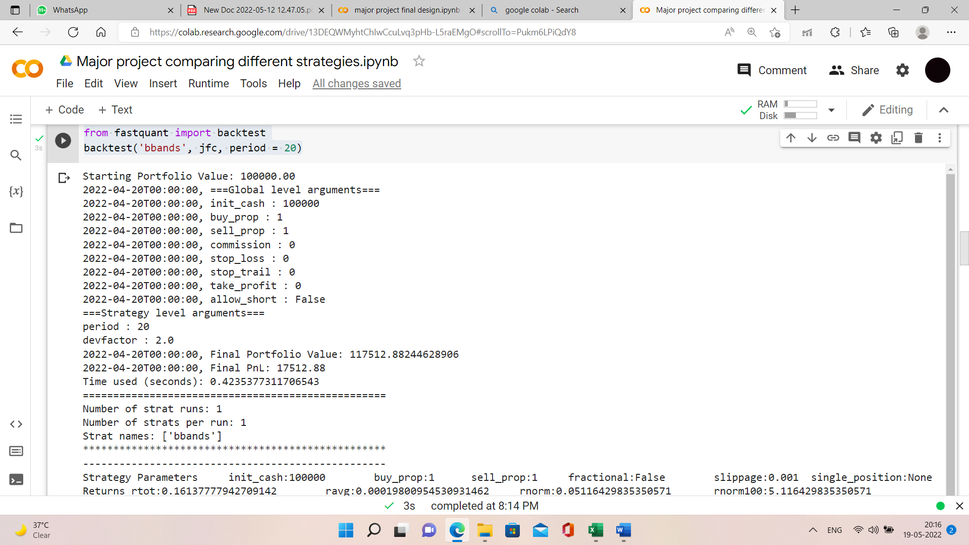

As you can see the profit accumulated over 3 years period by investing Rs. 100000 initially for this strategy is Rs. 17512.88

We performed the same operation to take out amount of profit for different number of periods ranging between 6 to 50.

We got the following results for different companies.

**Bollinger Bands Reliance Bar Graph**

**Bollinger Bands ITC Bar Graph**

**Bollinger Bands HDFC Bar Graph**

**Bollinger Bands TCS Bar Graph**

**Bollinger Bands IRCTC Bar Graph**

As you can see, the maximum profit generated by different no. of periods varied a lot in all of the cases. Therefore, in order to find the most stable parameter, we added the profits generated in all of the five companies vs different number of periods for which they generated those profits, which provided us with following result.

**Sum of profits of all companies vs number of periods(Bollinger Bands)**

As you can see the range of periods between 16 to 18 gave the most profitable results. But since the parameter of Bollinger Bands requires only one number so we decided to optimize BB indicator with the number of periods = 16.

After that, we deployed BB indicator strategy for buy and selling on Python in the following way.

**Bollinger Bands Code:-**

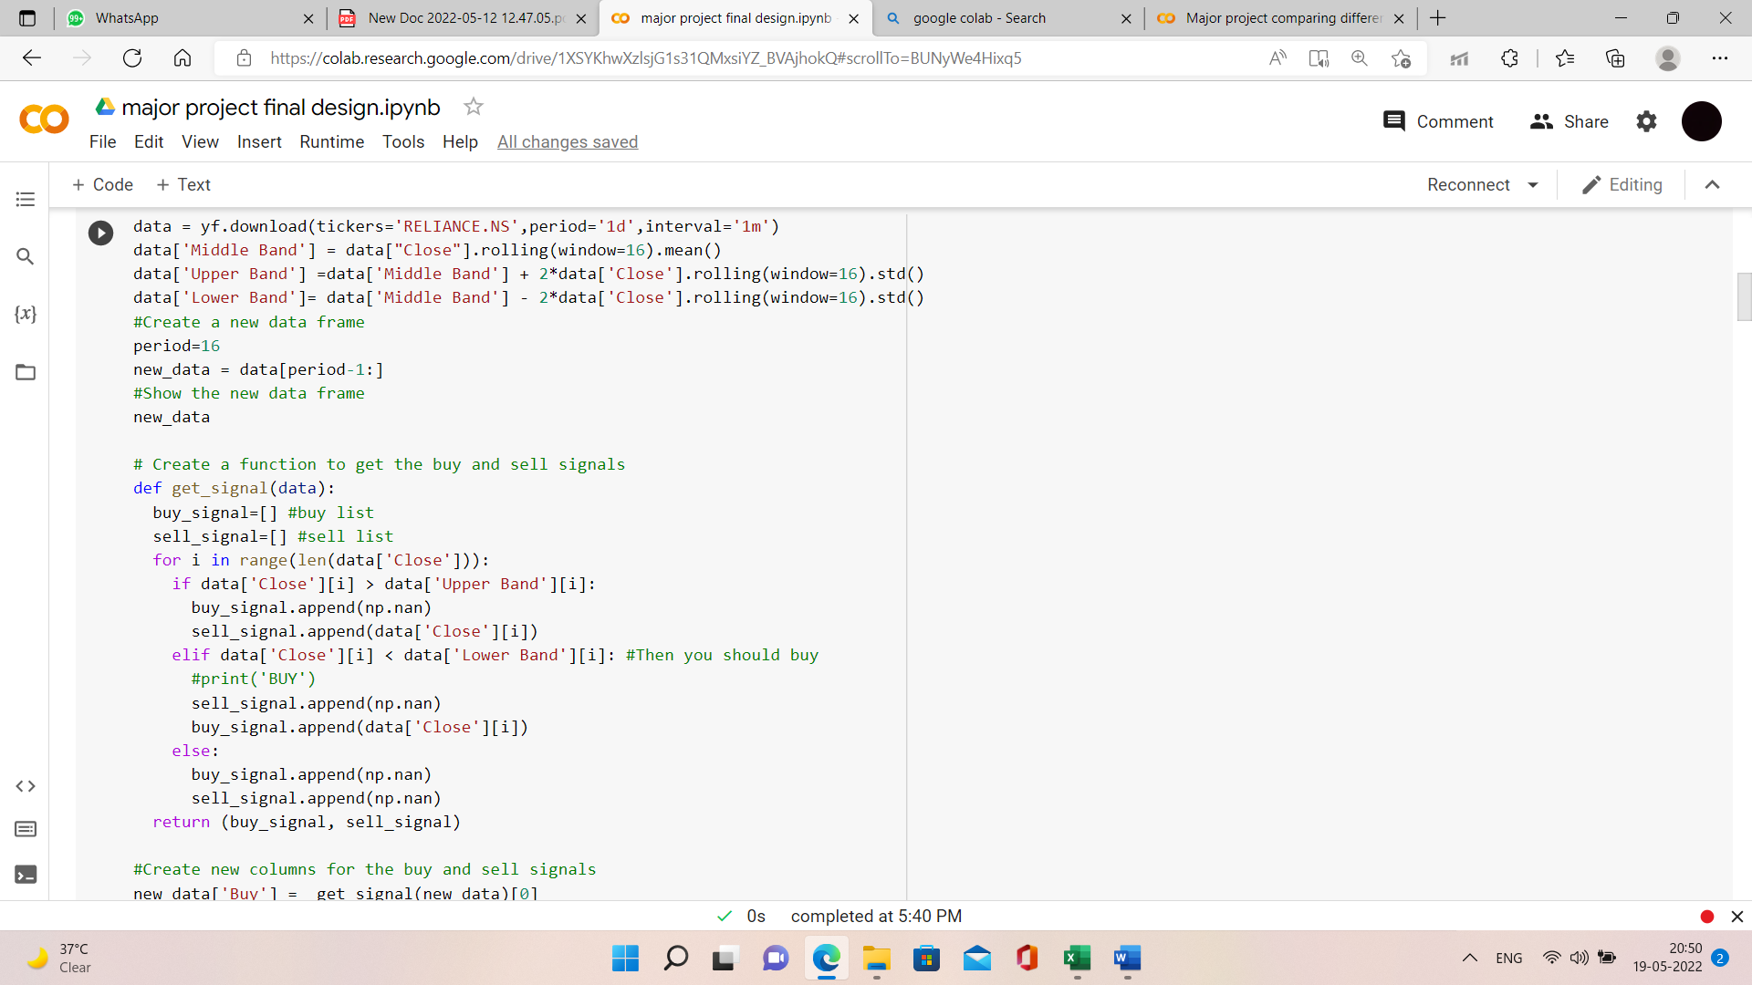

Then, we plotted the buy/sell signal using plotly.graph.



**Moving Average Convergence Divergence (MACD) Indicator: -**

To optimize MACD Indicator, we took help of fastquant library in Python to backtest different values for fast period EMA, slow period EMA and signal period EMA in MACD strategy. We did the same thing for 5 different companies in order to get our sample data for research in the following way.

*!pip install fastquant*

*from fastquant import get_stock_data*

*jfc = get_stock_data("RELIANCE.NS", "2019-01-01", "2022-04-21")*

(We took the historical closing price data of Reliance of 1st January 2019 to 21st April 2022.)

*from fastquant import backtest*

*backtest('macd', jfc, fast_period = 12, slow_period=26, signal_period=9)*

(Then we backtested MACD indicator buy/sell strategy for this 3-year data while keeping the fast period = 12, slow period = 26 and signal period = 9. We got the following output.)

**MACD Backtesting(Optimization):-**

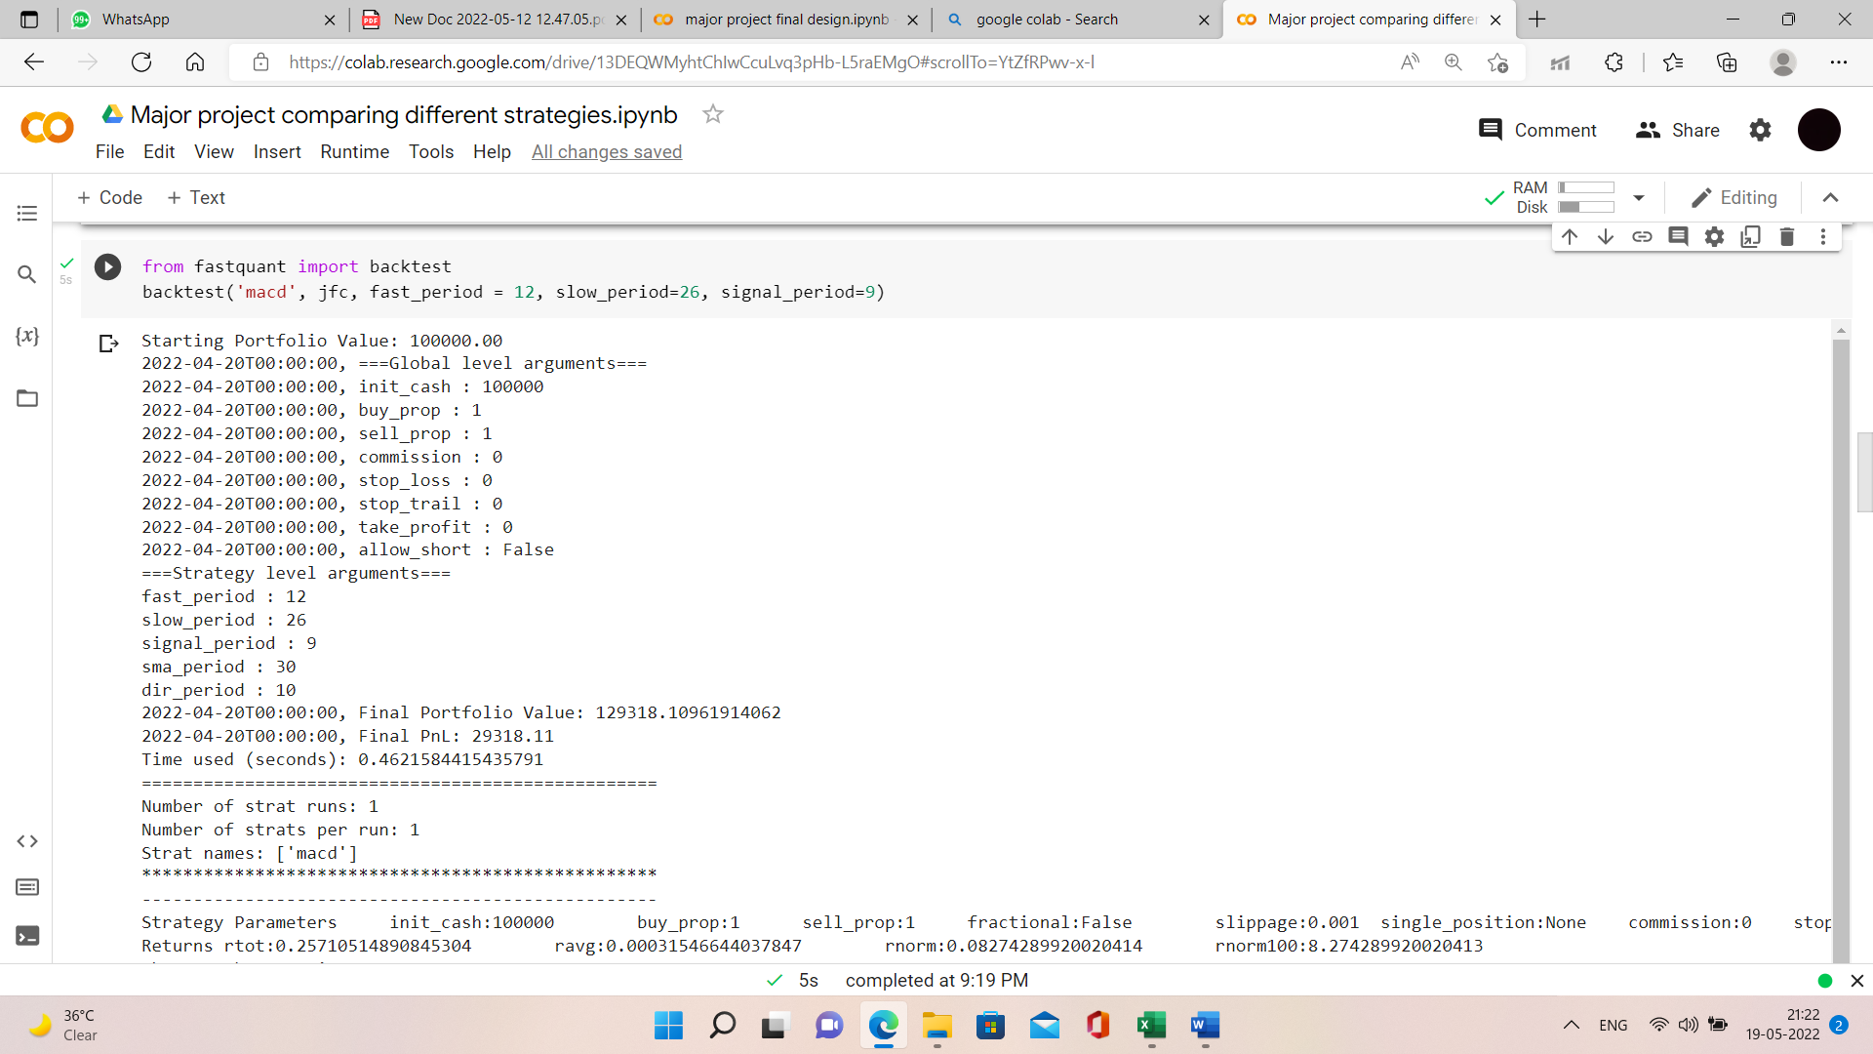

As you can see the profit accumulated over 3 years period by investing Rs. 100000 initially for this strategy is Rs. 29318.11

We performed the same operation to take out amount of profit for different combinations of different number of fast periods, slow periods and signal periods.

We got the following results for different companies when we ran over 400 simulations for every company. And out of this, here are the top 20 most profitable combinations of parameters for every company.

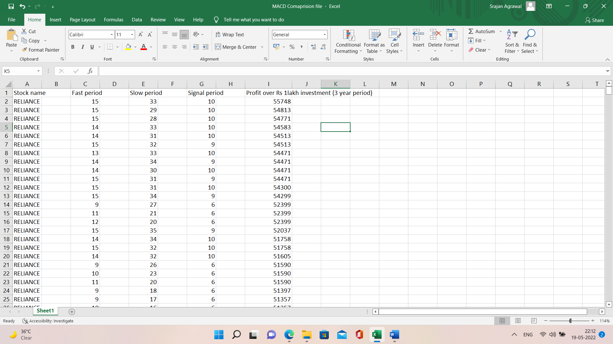

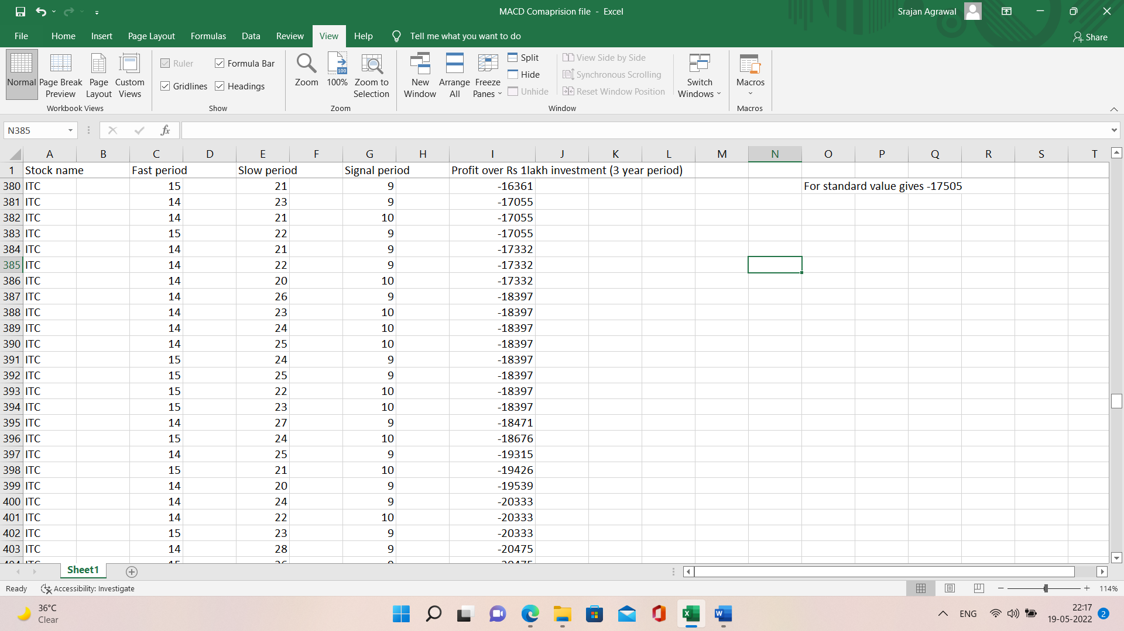

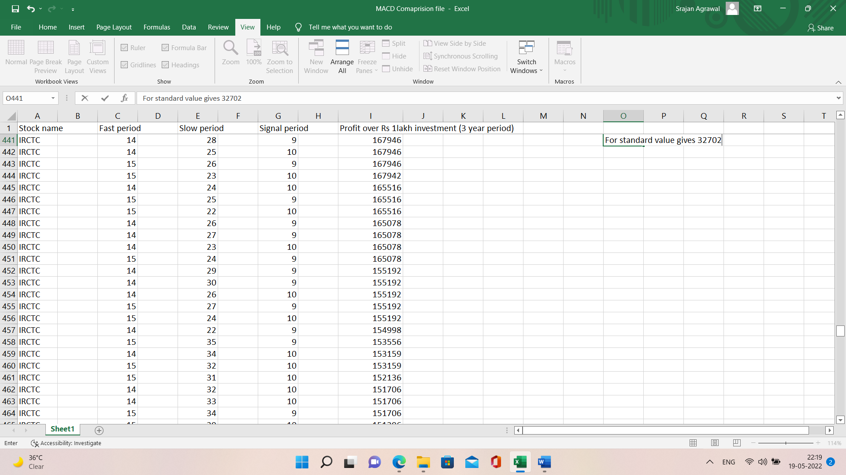

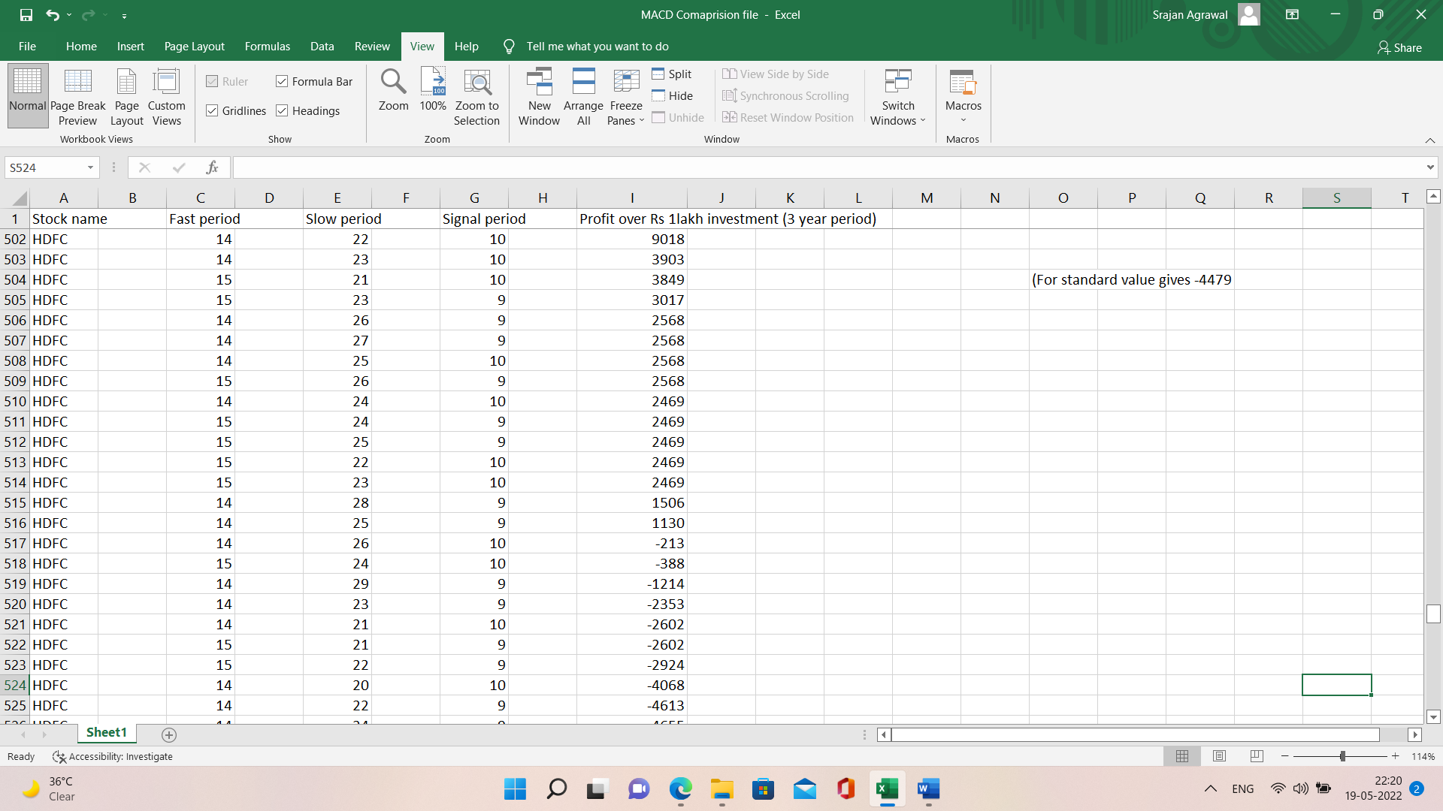

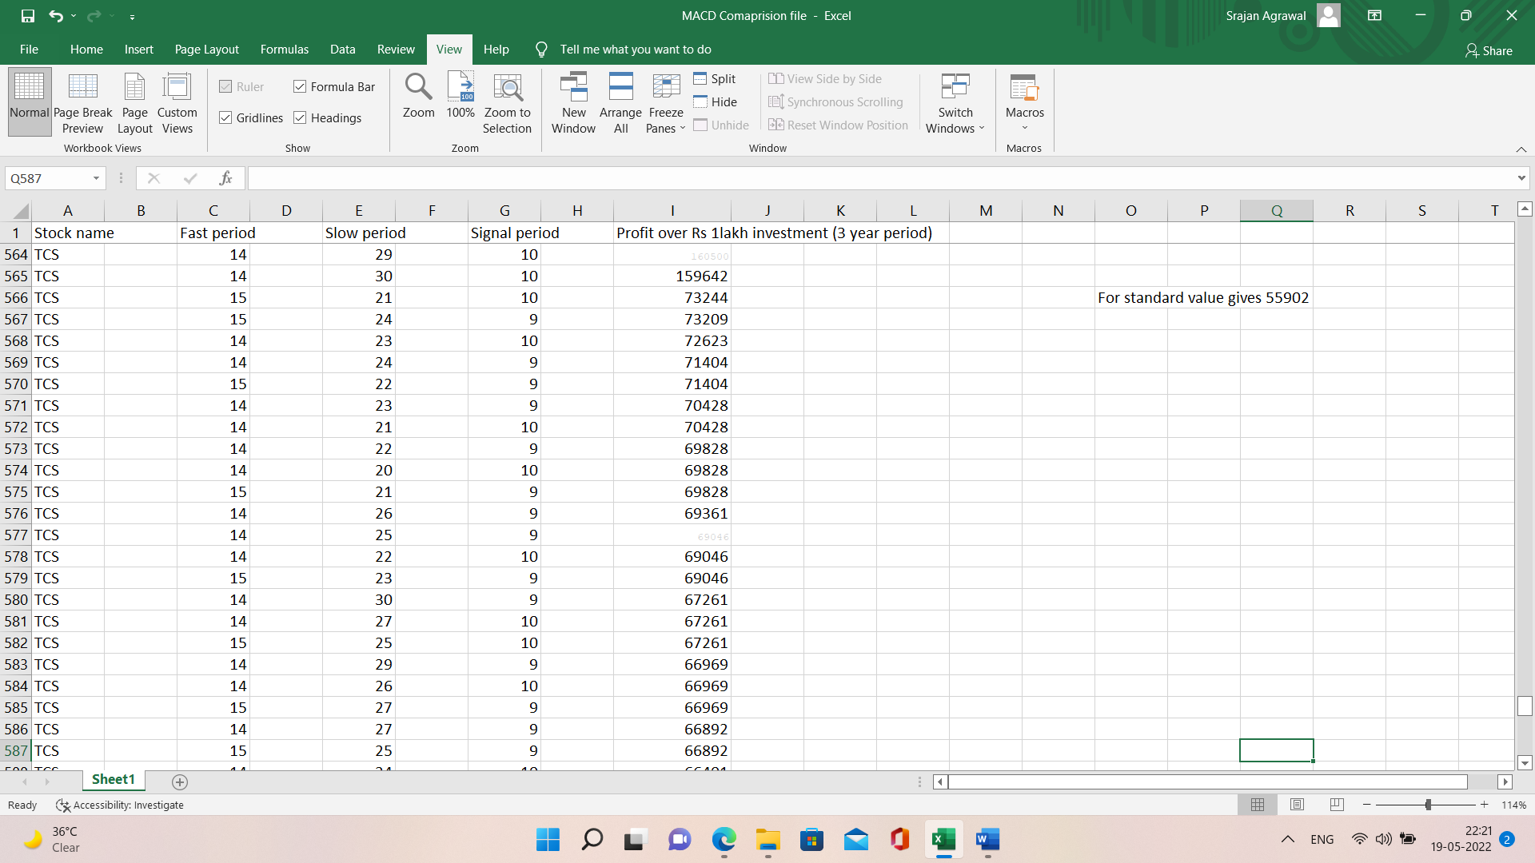

As you can see, the maximum profit generated by different combinations of parameters varied a lot in all of the cases. Therefore, in order to find the most stable parameter, we found the set of parameters for which every stock generated consistent profits or least amount of loss. Therefore, we picked, fast period = 14, slow period = 23, signal period = 10 for MACD parameters.

After that, by keeping the above-mentioned parameters, we deployed MACD indicator strategy for buy and selling with the help of TA-lib library on Python in the following way.

**MACD Code:-**

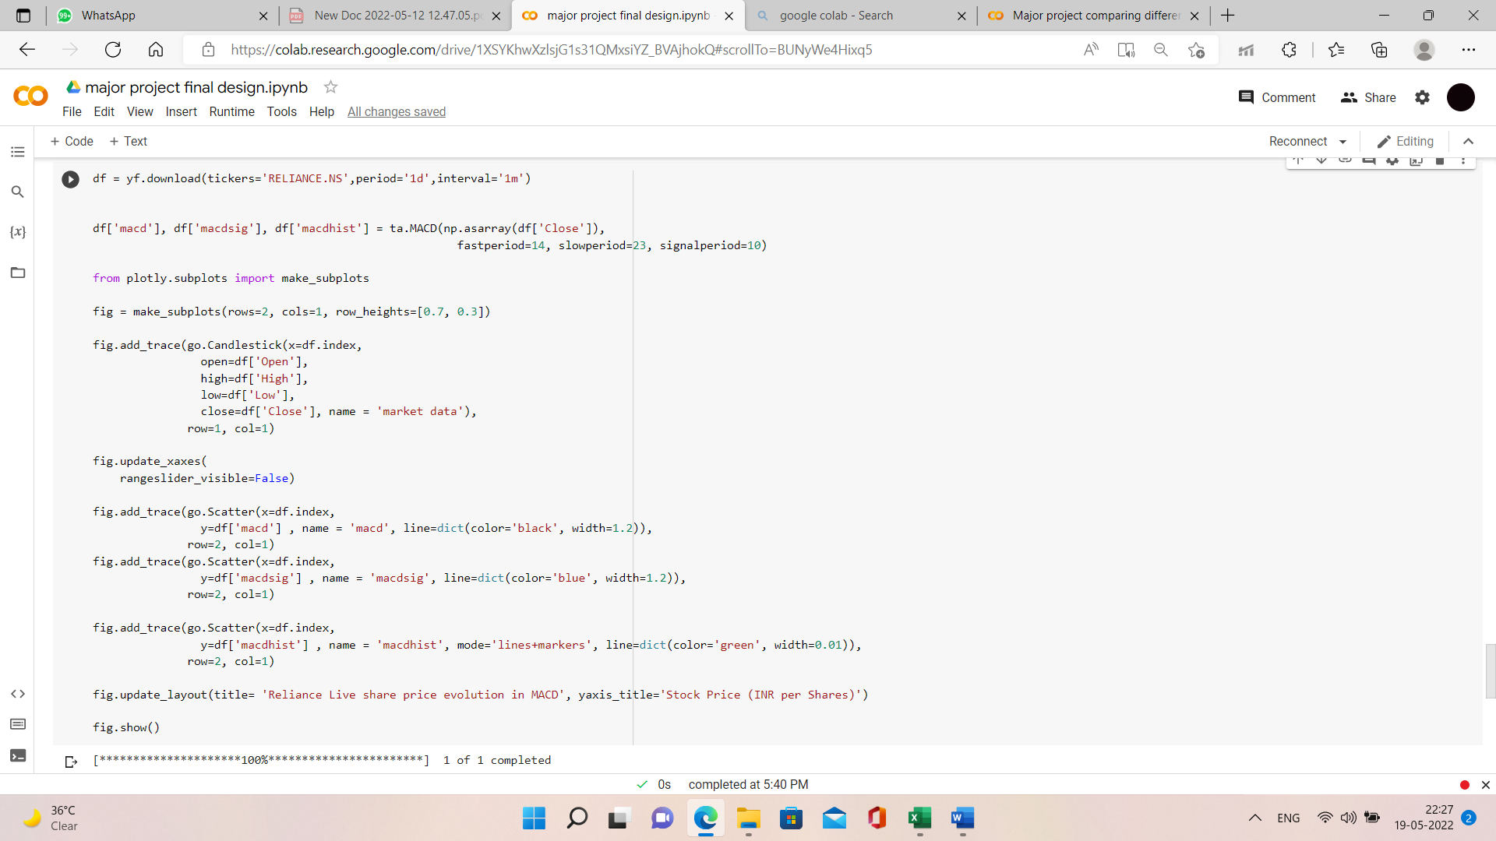

This yielded the following trend line for users.



**Supertrend Indicator: -**

For Supertrend indicator, we took help of optimization algorithm to find the optimized values of ATR and multiplier for supertrend indicator in the following manner.

**Supertrend Optimization Code:-**

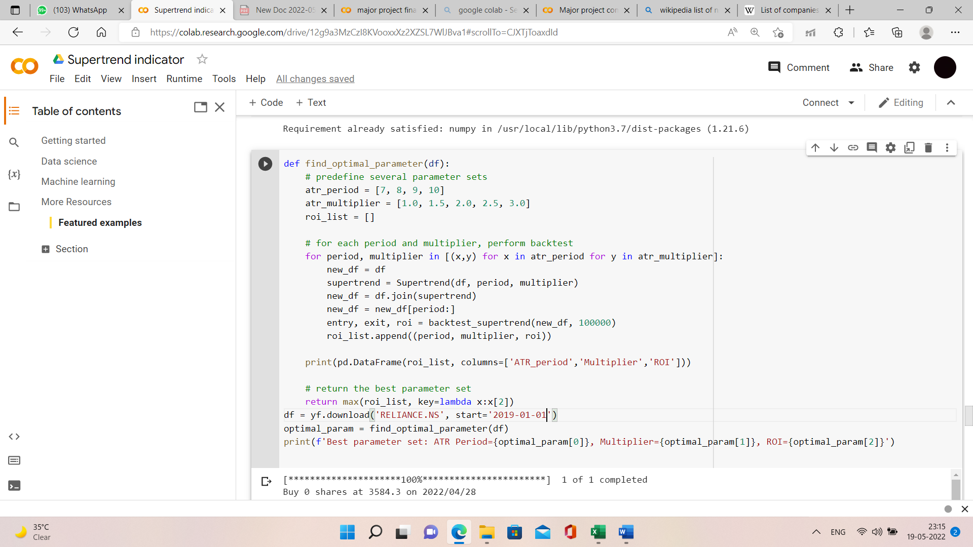

The above algorithm yielded the following results for the Reliance company stock traded over for past 3 years using the Supertrend Indicator strategy.

**Supertrend Optimized Result:-**

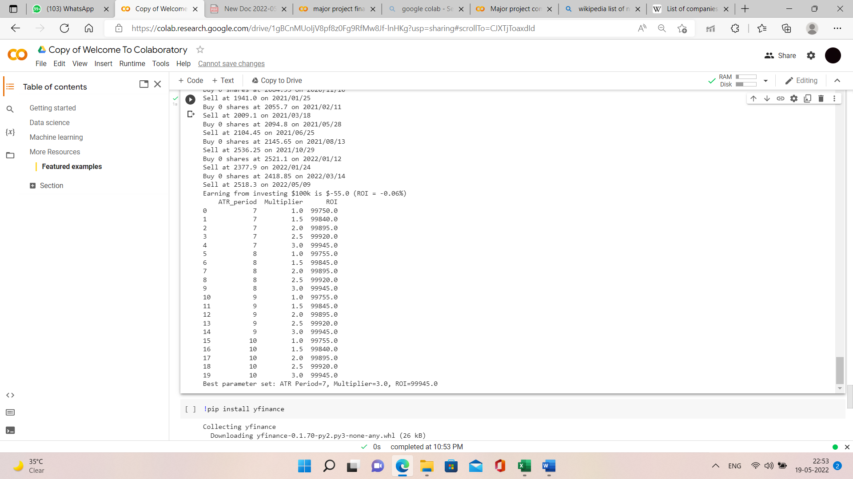

Similarly, the optimized values for other companies using the same strategy are as follows.

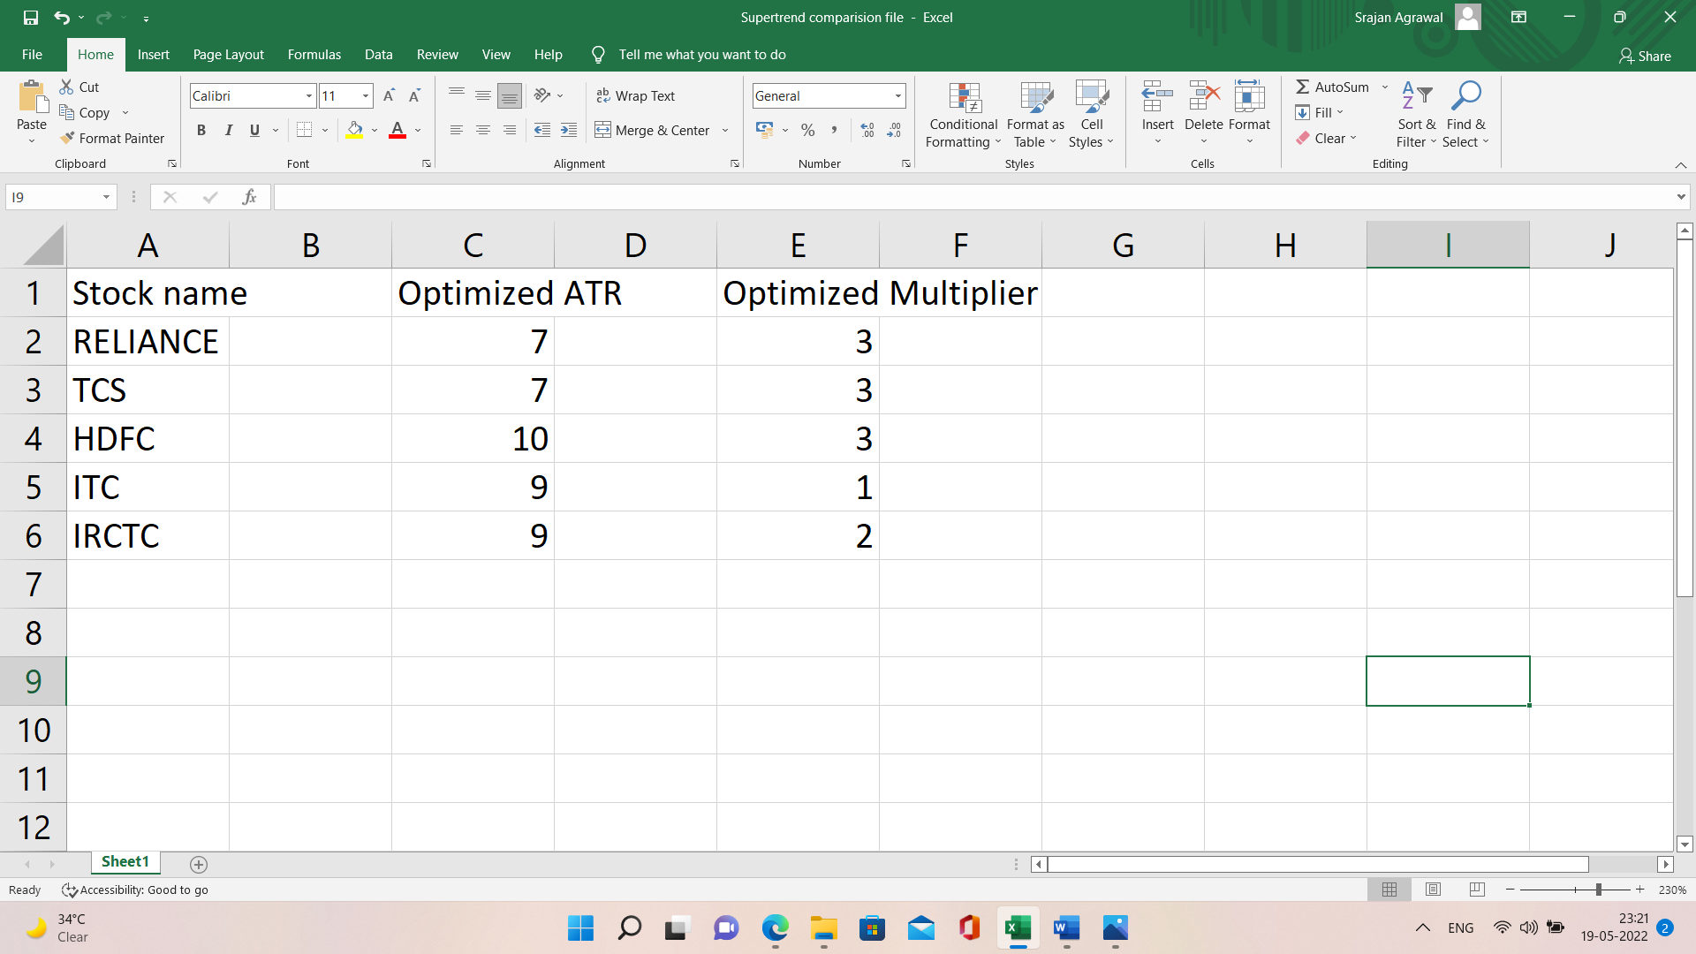

As you can see that the combination of ATR = 7 and Multiplier = 3 yielded maximum profit for the greatest number of times. Therefore, we optimized supertrend indicator with these parameters in order to develop supertrend indicator trading strategy in the following way.

**Supertrend Code: -**

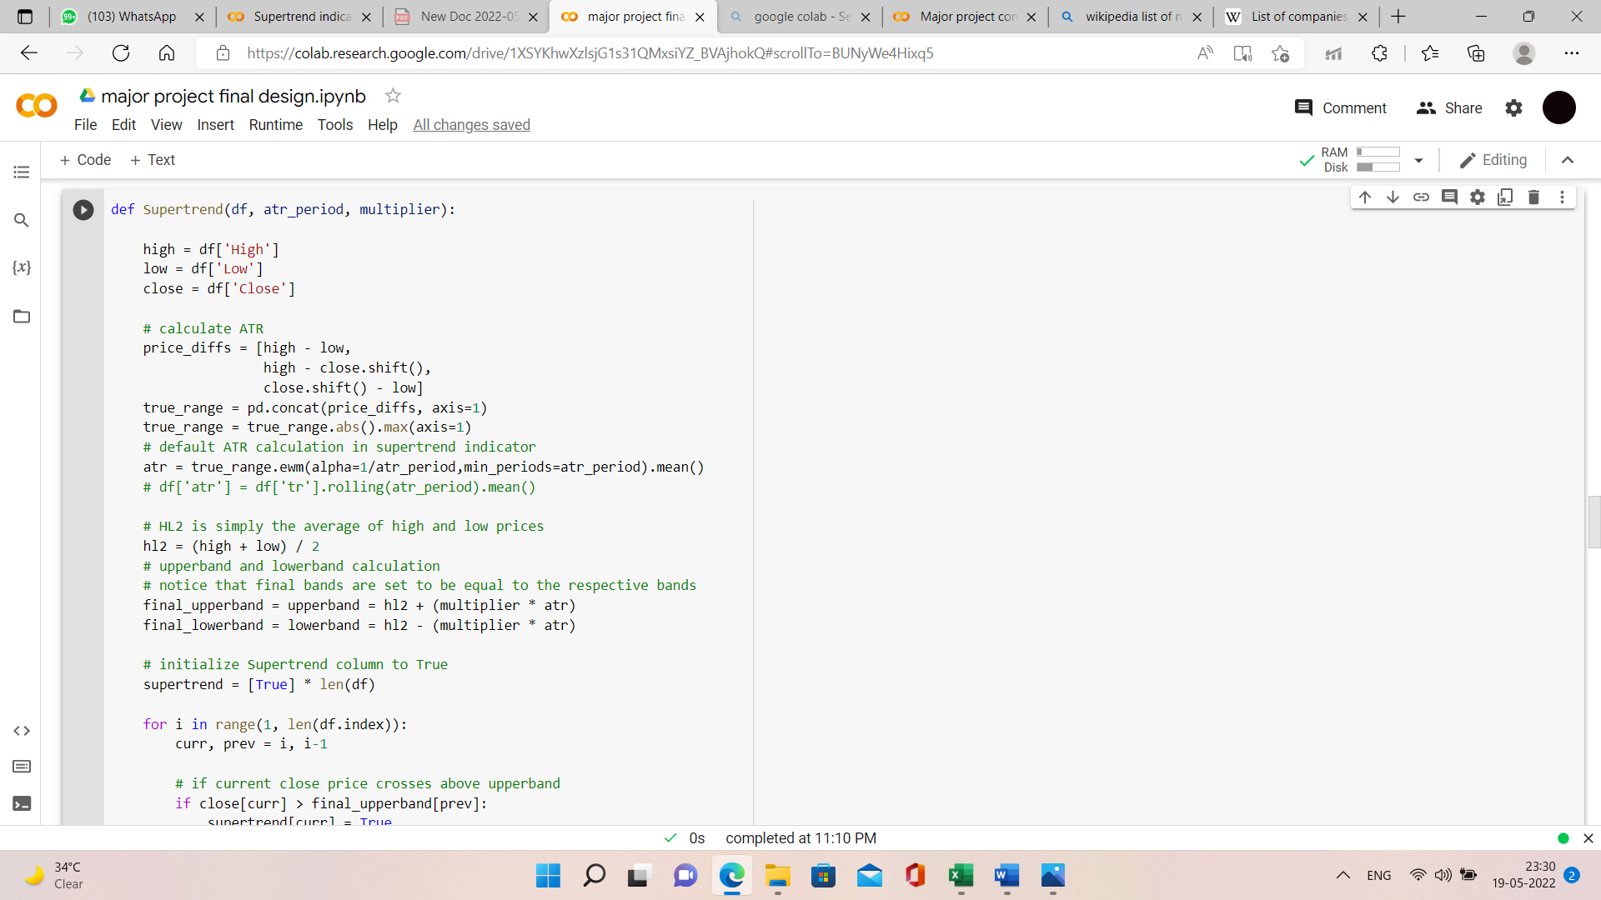

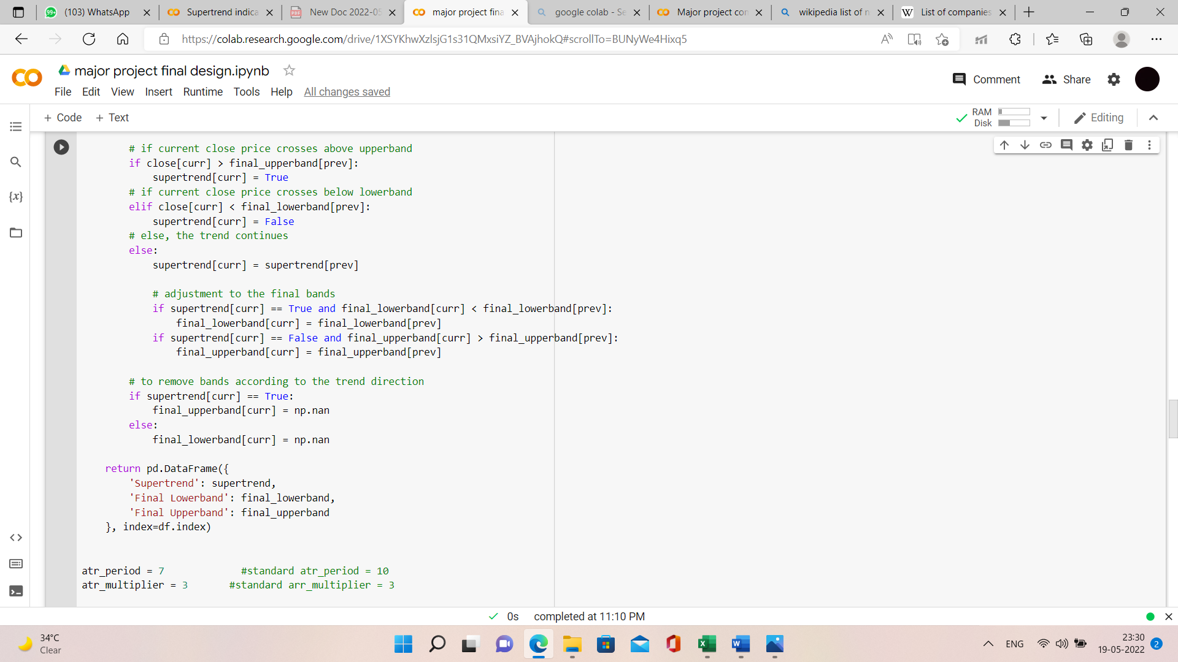

With the optimized set of parameters, the above strategy gave the following results in the form of graph plotted using plotly.graph



**Relative Strength Indicator (RSI): -**

Similarly, we tried optimizing RSI indicator based on the same approach of our research but we found a conclusory result that since RSI is a momentum indicator and momentum is a very fickle part of stock market so it is not wise to bound RSI in a range. Therefore, we propose an alternate option to user; where based on the current market condition, he will automatically be provided with the best optimal RSI range against the most commonly used RSI range of 30 to 70. We tried implementing our approach using the TA-Lib library in python.

**RSI Code: -**

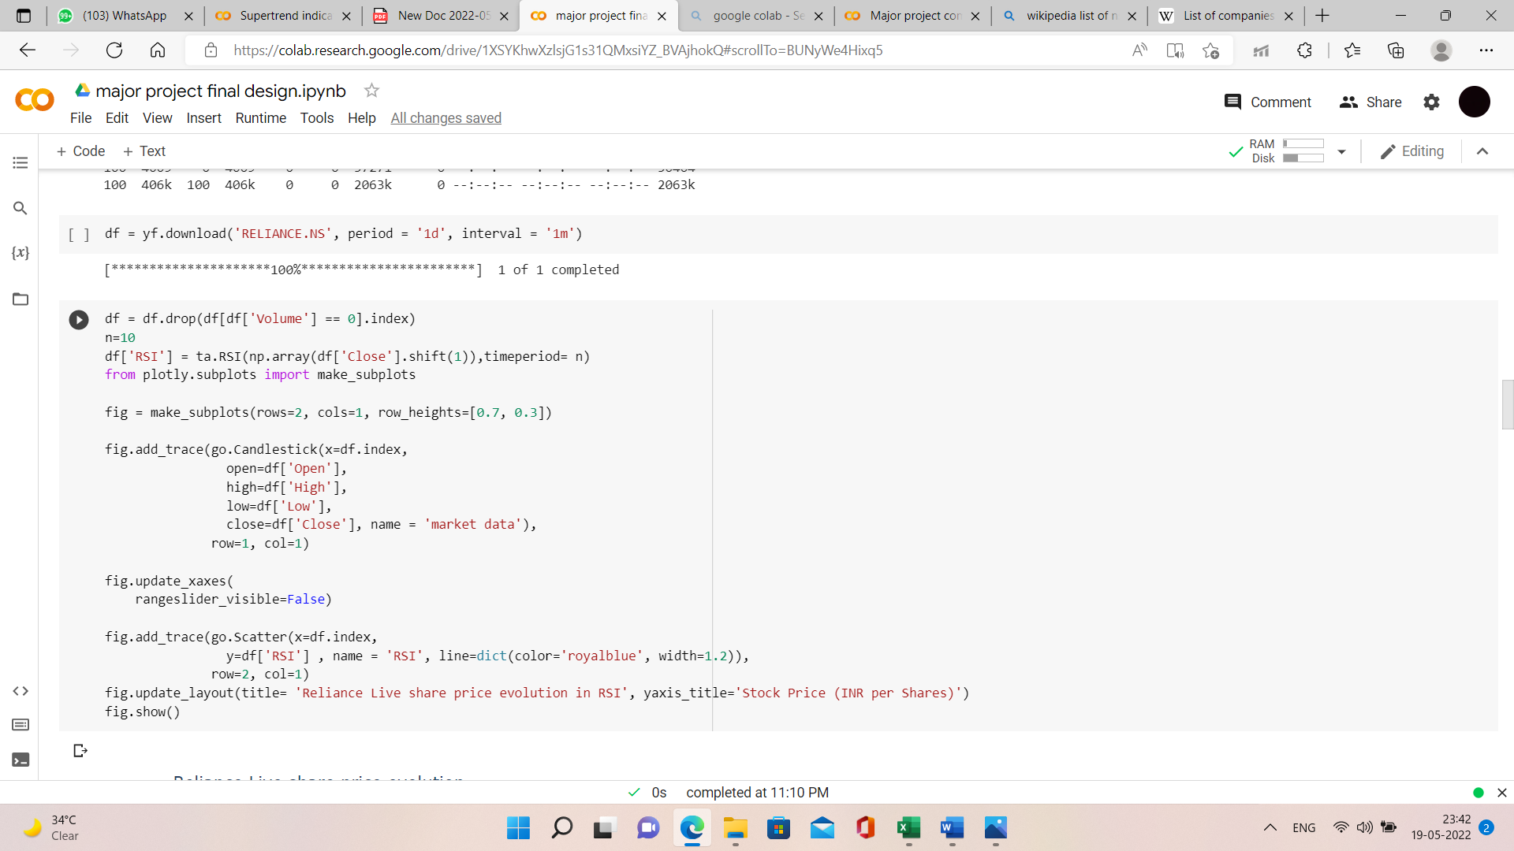

Our algorithm provides user with the following result in the form of graph.



**5.4 Result Analysis with Previous Methods**

**Bollinger Bands Indicator: -**

**Sum of profits of all companies vs number of periods(Bollinger Bands)**

The default number of periods used in BB indicator is 20 which is giving a combined profit of Rs. 1,30,319 for over Rs 1 lakh traded in 5 different companies for 3 years. But, our proposed value for BB indicator, i.e., number of periods = 16 is giving a combined profit of Rs. 1,74,778 for over Rs 1 lakh traded in 5 different companies for 3 years. This profit is more than the profit earned by using default parameter by Rs. 44,459.

Our proposed parameter: No. of periods = **16**

Default parameter: No. of periods = **20**

Our proposed parameter is **34.11% more efficient** than the default parameter.

**Moving Average Convergence Divergence (MACD) Indicator: -**

For the standard value of the parameters used in MACD indicator, the algorithm yields the following amount of total profit, i.e., Rs. 97,564

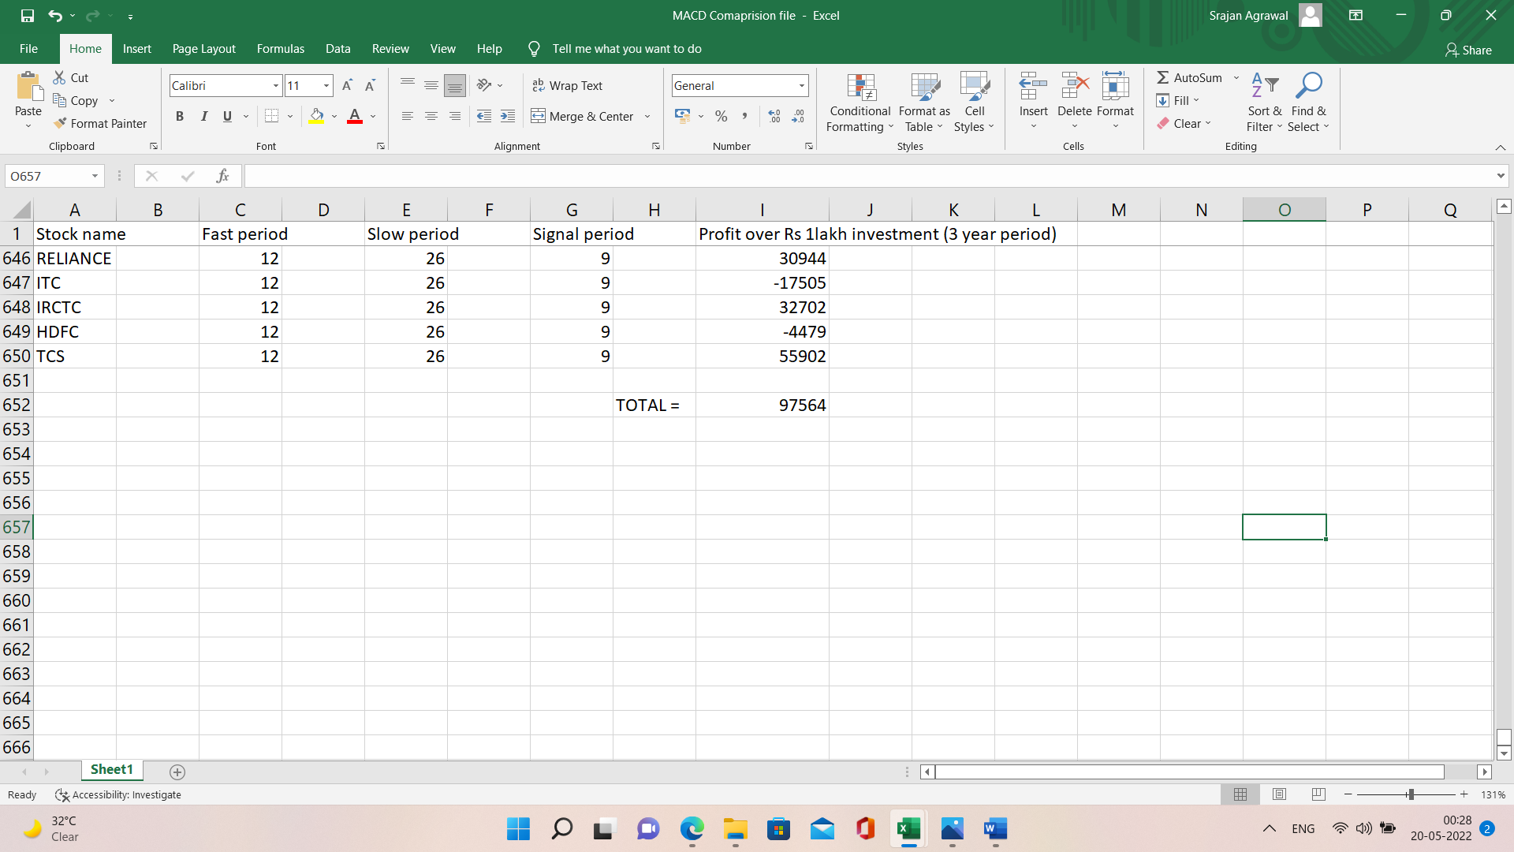

But, for the values of the parameters proposed by us, the algorithm yields the following amount of total profit, i.e., Rs. 2,57,090

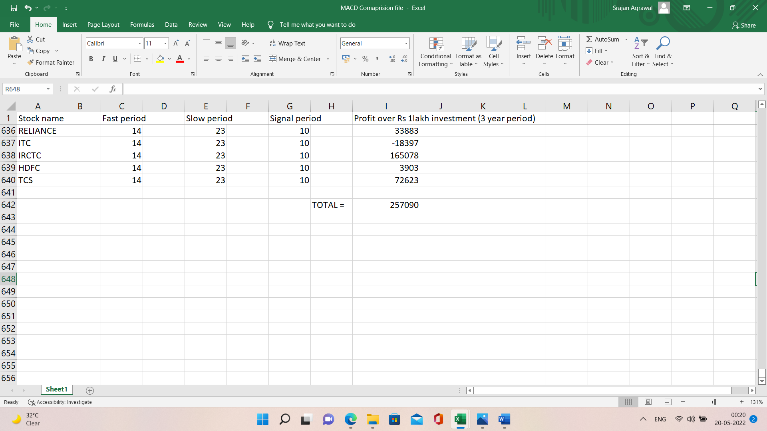

Our proposed parameter: fast period = **14**, slow period = **23**, signal period = **10**

Default parameter: fast period = **12**, slow period = **26**, signal period = **9**

Our proposed parameter is **163.50 % more efficient** than the default parameter.

**Supertrend Indicator: -**



As you can see that the combination of ATR = 7 and Multiplier = 3 yielded maximum profit for the greatest number of times in against with default combination of ATR = 10 and Multiplier = 3.

Our proposed parameter: ATR = **7**, Multiplier = **3**

Default parameter: ATR = **10**, Multiplier = **3**

**Relative Strength Indicator (RSI): -**

We tried optimizing RSI indicator based on the same approach of our research but we found a conclusory result that since RSI is a momentum indicator and momentum is a very fickle part of stock market so it is not wise to bound RSI in a range. Therefore, we propose an alternate option to user; where based on the current market condition, he will automatically be provided with the best optimal RSI range against the most commonly used RSI range of 30 to 70.

* 1. **Conclusions: -**
* For Bollinger Bands indicator, our proposed parameter, i.e., number of periods = 16 is 34.11% more efficient than the default parameter, i.e., number of periods = 20.
* For MACD indicator, our proposed set of parameters, i.e., fast period = 14, slow period = 23, signal period = 10are 163.50 % more efficient than the default set of parameters, i.e., fast period = 12, slow period = 26, signal period = 9.
* For Supertrend indicator, our proposed set of parameters, i.e., ATR = 7, Multiplier = 3 are 100 % more efficient than the default set of parameters, i.e., ATR = 10, Multiplier = 3.
* For RSI indicator, we propose an alternate option to user; where based on the current market condition, he will automatically be provided with the best optimal RSI range against the most commonly used RSI range of 30 to 70.

**6. Conclusion and Future Direction**

* For Bollinger Bands indicator, our proposed parameter, i.e., number of periods = 16 is 34.11% more efficient than the default parameter, i.e., number of periods = 20.
* For MACD indicator, our proposed set of parameters, i.e., fast period = 14, slow period = 23, signal period = 10are 163.50 % more efficient than the default set of parameters, i.e., fast period = 12, slow period = 26, signal period = 9.
* For Supertrend indicator, our proposed set of parameters, i.e., ATR = 7, Multiplier = 3 are 100 % more efficient than the default set of parameters, i.e., ATR = 10, Multiplier = 3.
* For RSI indicator, we propose an alternate option to user; where based on the current market condition, he will automatically be provided with the best optimal RSI range against the most commonly used RSI range of 30 to 70.

Evidently, Algorithmic Trading Algorithms are an everlasting field which will keep on evolving always because the condition of market is dependant on live price action which is in turn dependant on human sentiments. There is a limitation to what algorithms can do. In our research, we successfully optimized Bollinger Bands indicator, MACD indicator and Supertrend indicator whereas we were unable to find out the most optimal and universal range for RSI so we proposed an alternate option to user; where based on the current market condition, he will automatically be provided with the best optimal RSI range against the most commonly used RSI range of 30 to 70. But with more knowledge and research, we might be able to derive a universal range for RSI too. We are moving forward in the same direction and at the same time we would also look forward for the ways to further optimize other technical indicators too.

**REFERENCES**

* “A Study on Technical Analysis and its usefulness in Indian Stock Market” Mirror, 3, (2), 159-165. ISSN: 2249-8117. Authors - Dr. Asha E. Thomas Asst. Professor in P.G. Dept. of Commerce St. Paul’s College, Kalamassery
* “A Study on the Technical Analysis of NSE Towards it Stocks with Reference to Indian Stock Market” International Journal of Advances in Management and Economics ISSN: 2278-3369. Authors - Valarmathi A, Kowsalya P Vivekananda Institute of Management Studies, Coimbatore, India.
* “Investment Decision Making Using Technical Analysis: A Study on Select Stocks in Indian Stock Market” IOSR Journal of Business and Management e-ISSN: 2278-487X, p-ISSN: 2319-7668. Authors - Pushpa BV, Sumithra C.G, Madhuri Hegde M.P. Birla Institute of Management, Associate Bharatiya Vidya Bhavan, Bengaluru.
* “A Comparative Study on Technical Analysis by Bollinger Band and RSI” International Journal in Management and Social Science ISSN: 2321-1784 Authors - Shah Nisarg Pinakin, Patel Taral Manubhai B.V. Patel Institute of BMC & IT, Bardoli, Gujarat.
* “Optimization of MACD and RSI indicators: An Empirical Study of Indian Equity Market for Profitable Investment Decisions” Authors - Dr. Yogesh D Mahajan, Associate Professor, Symbiosis International University. Dr. Krishnamurthy Inumula Symbiosis institute of International Business, Pune
* “Simulation of Technical Indicators for Better Profits in the Indian Stock Market” International Journal of Recent Technology and Engineering ISSN: 2277-3878 Authors - Krishna Murthy Inumula, Anupama Tadamarla, K.Deeppa